Ongoing Art class with Inst:
Mwasaa Sherard
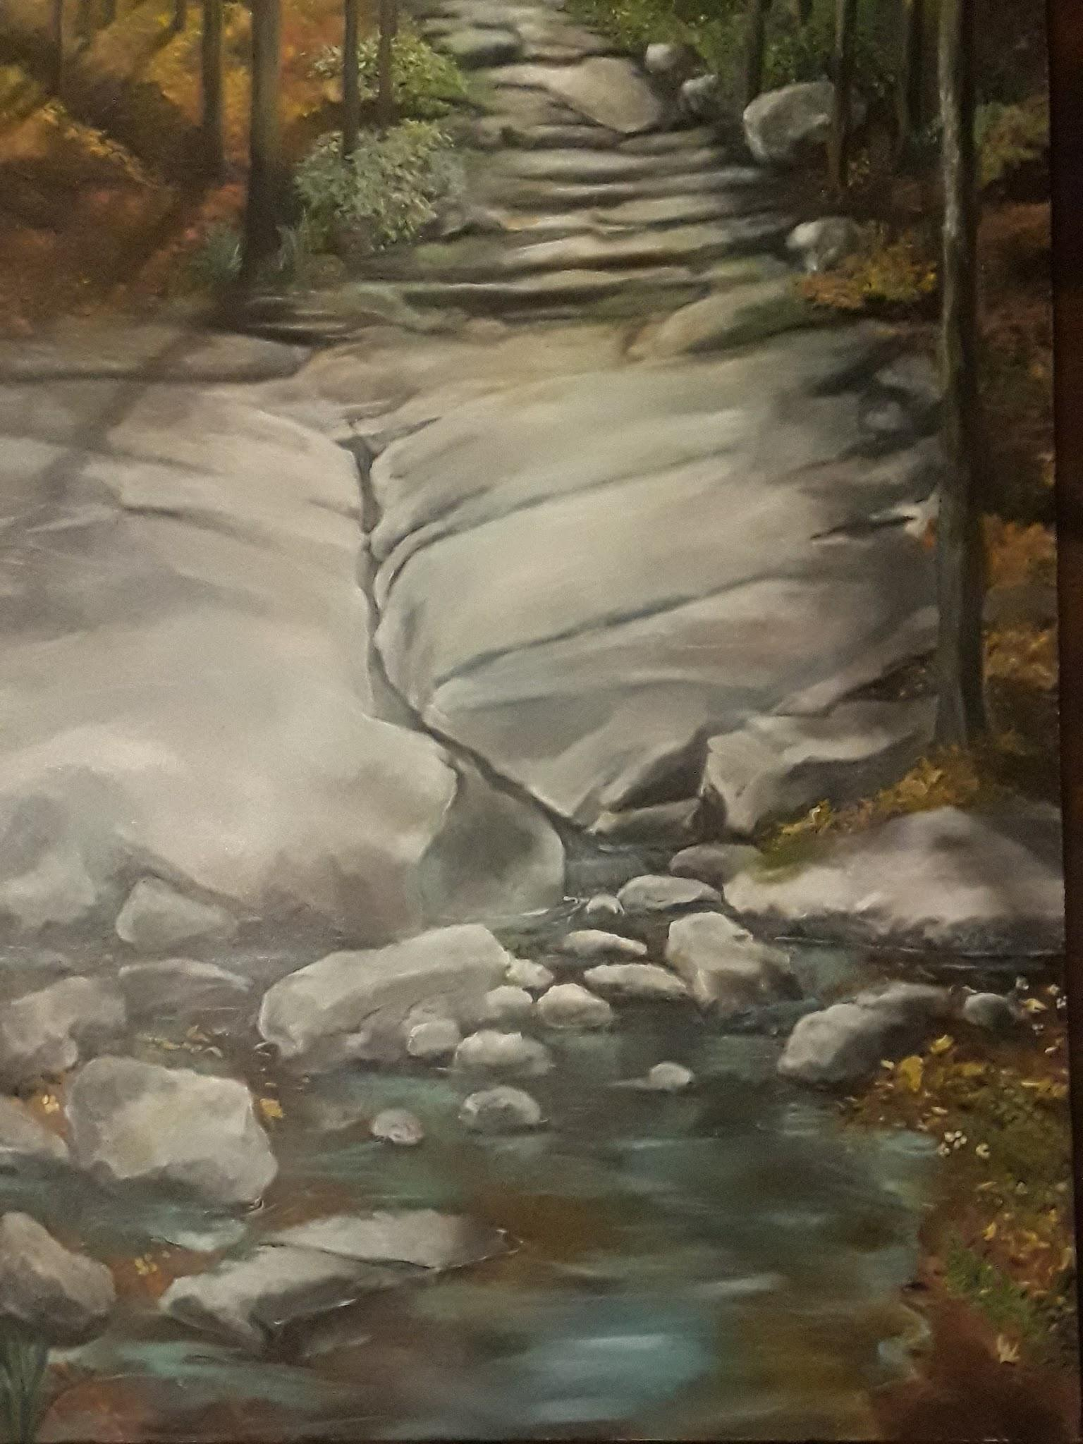
MwasaasArtSpaceStudio.com
Beginning: Starting February 3 - March 24 , 2019
Time: Sundays at 3:00 - 4:00 PM
Location: Mwasaa’s Studio Stone Mountain GA 300232
Courses available this spring / Summer 2018
Art class for ages 16 to Adult

- Six weeks Beginning and Intermediate Oil Painting II.,
Six Week session $170.00, or( $35 per daily drop In.)
Dates; Feb. 3, 10, 24 Mar, 3, 10, 24 , or 31
Description
Mwasaa Sherard professional painter and art teacher will be teaching beginning and intermediate Oil painting. The course will be focused on introductory exercise in class and students first, to the medium, tools and techniques and building on basic practices and allowing students to practice with short exercise in and outside of the class time. The goal will be to progress toward individual subjects and projects. Each class will end with reflection and display of culminating projects.
Registration
Your registration, class policies and payment are to be made and finalized through email please registration. Click to begin registration and then click the link. Register here. Or request registration by emailing: Mwasaa50@gmail.com, or call for info 404-396-4091.
Materials and supplies
Initial supply will be free on the first day and supply list will be available at 1st class. The course description and supply list will be available at first meeting. Feel free, as we work to bring personal supplies, personal subjects, images or objects for individual projects. Specific exercises and practices will take place at each meeting.

